[E122] Boil heater element

Remove the heat insulations.

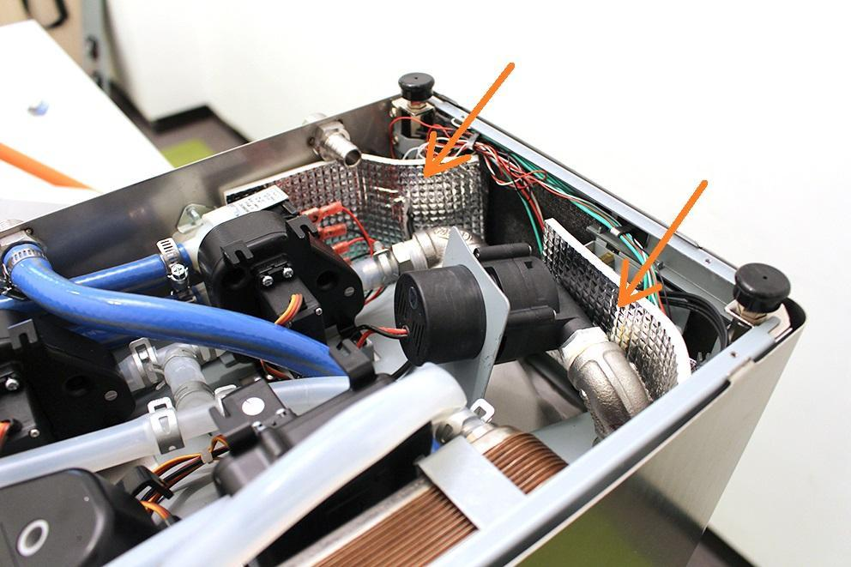

Unscrew the strain relief lock nut.

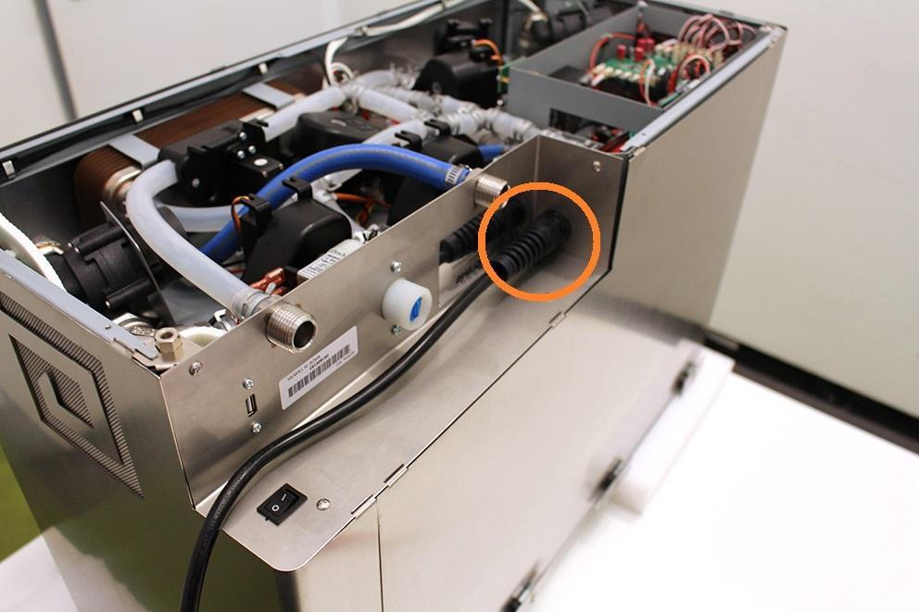

Remove the wort outlet hose clamp, pull off the wort outlet silicone tube and unscrew the indicated screws.

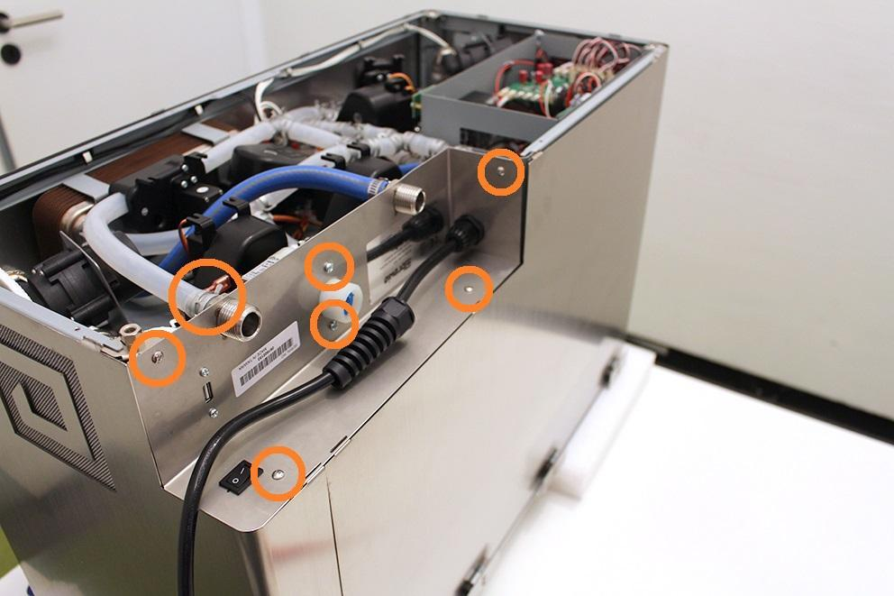

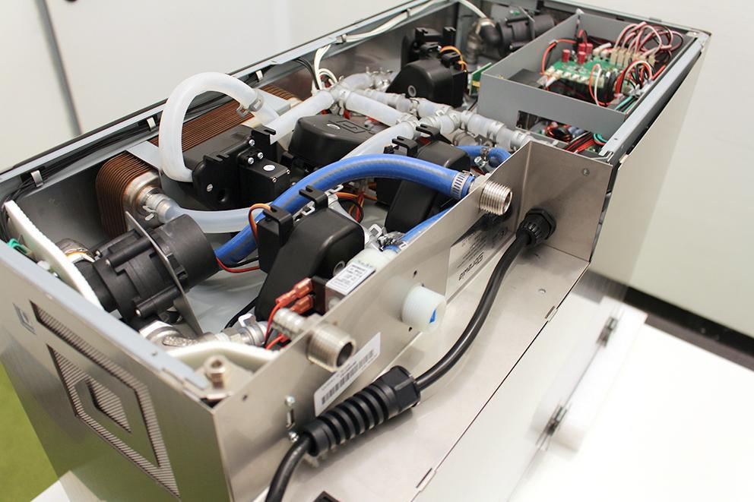

Remove the USB plug. Make sure that the washers don’t fall under the assembly plate. Use magnet for this step.

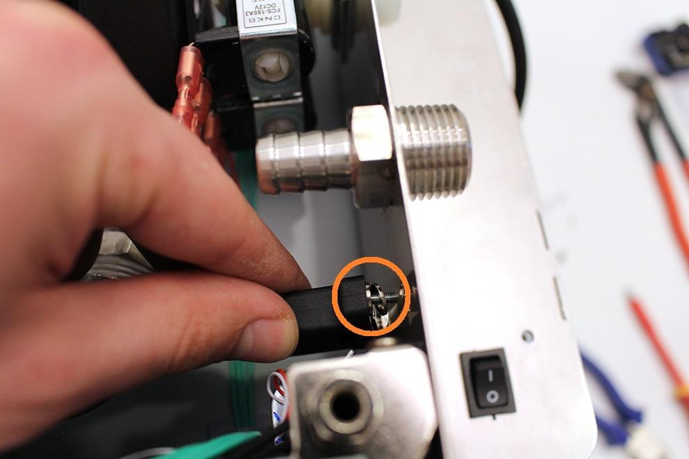

Loosen the indicated hose clamp and remove the high pressure hose from the fitting.

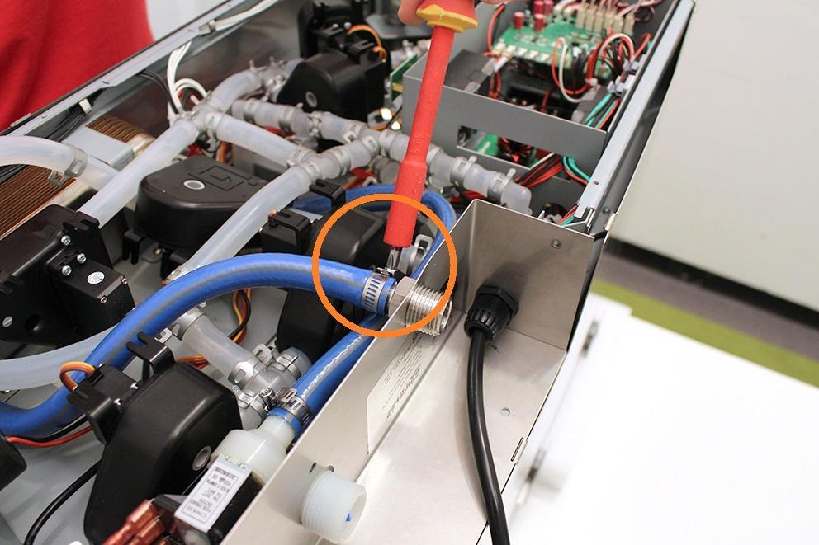

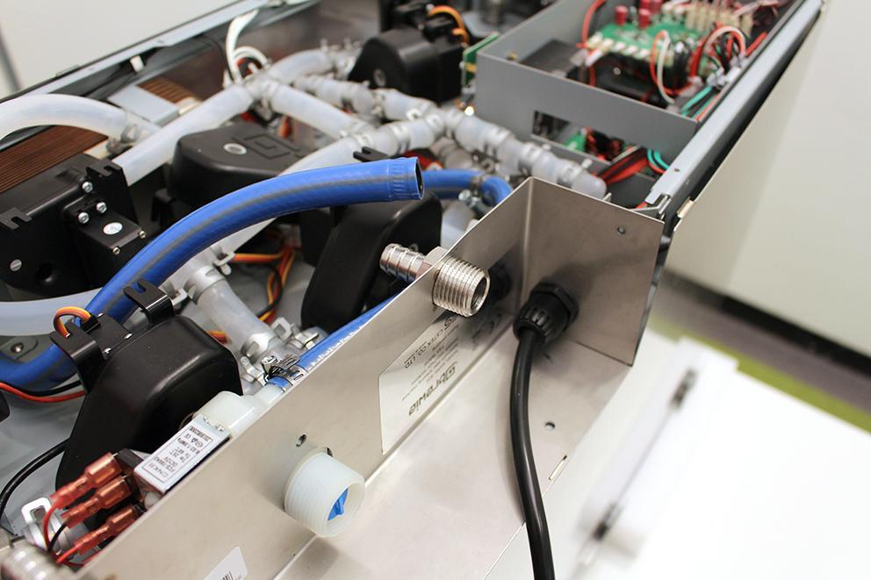

Lift the sheetmetal part carefully and disconnect the indicated plugs with a screwdriver.

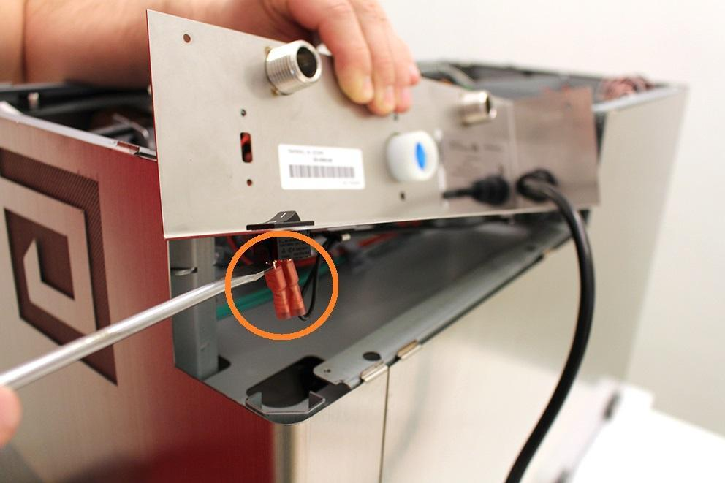

Remove the cables from the cable clips.

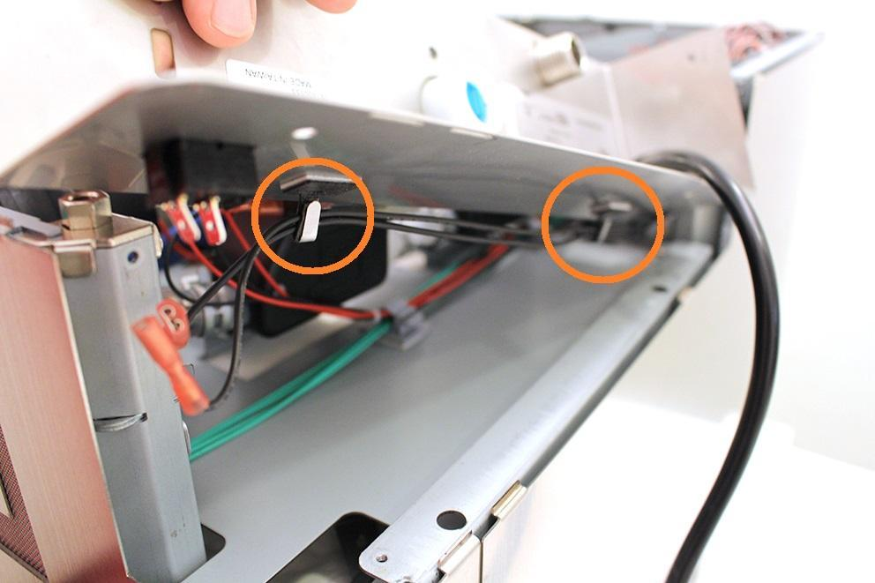

Pull off the high pressure valve from the sheetmetal. Pull off the sheetmetal on the power cable and put it on a safe place.

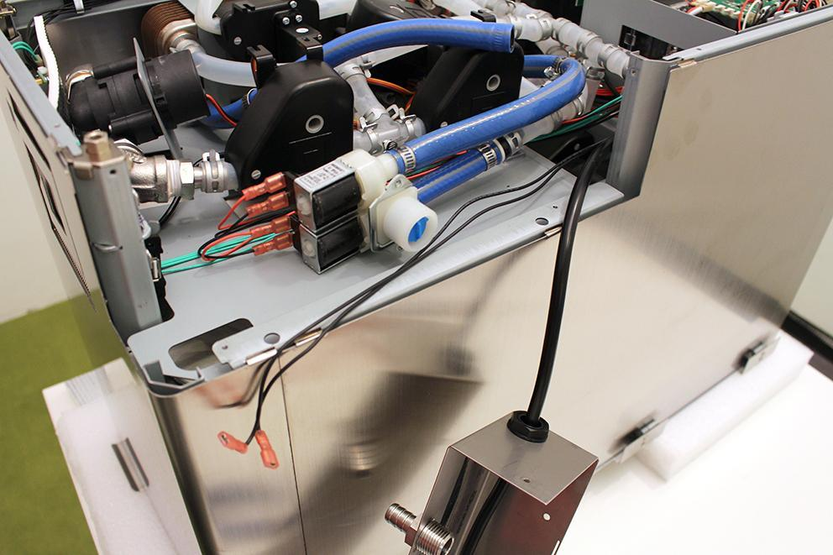

Remove the indicated heat insulation and remove the indicated cable tie.

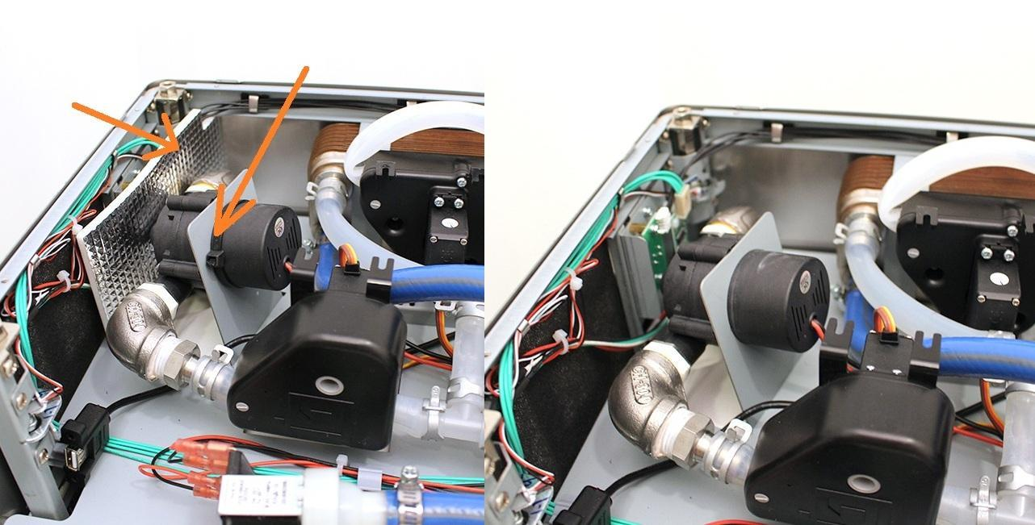

Pull off the pipe clamp from the encircled fitting. Pull off the silicone hose from the fitting.

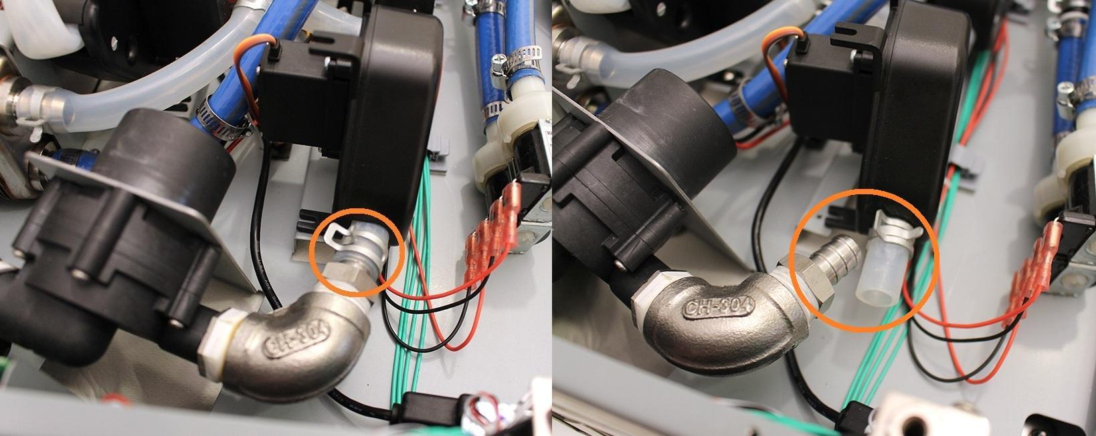

While you loosen the indicated hose clamp, you can pull off the pump from the silicone tube by rotating the pump around its axis.

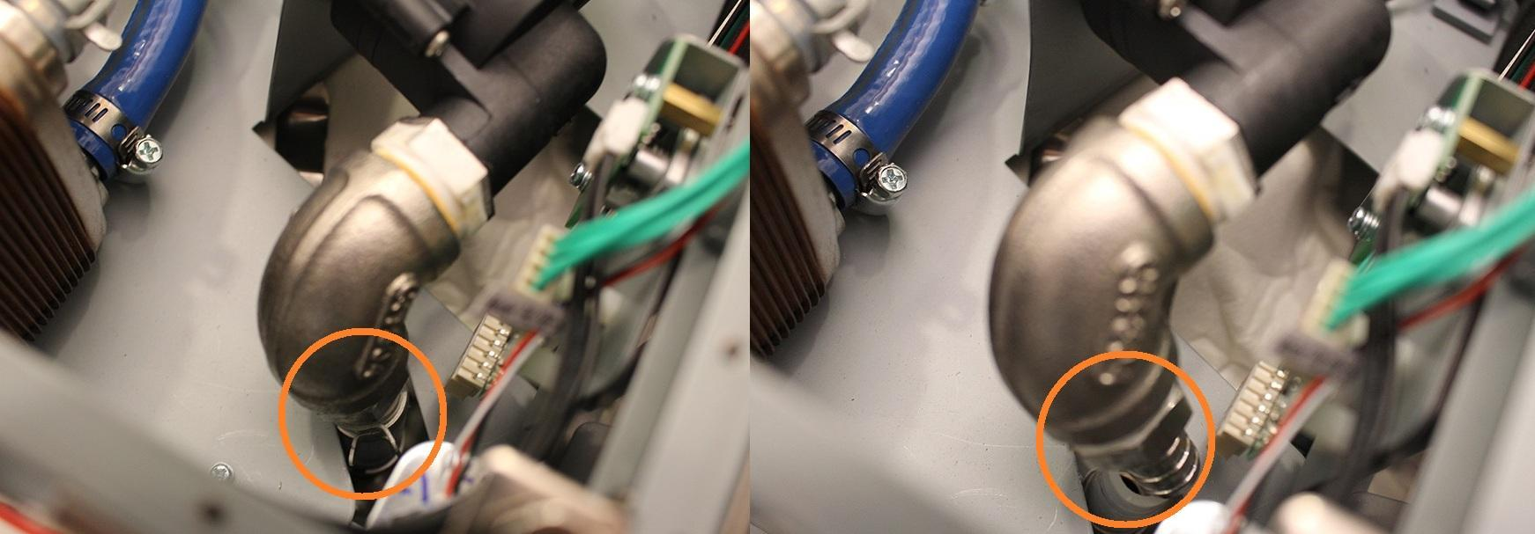

Bend the pump holder sheetmetal carefully in order to remove the pump easier.

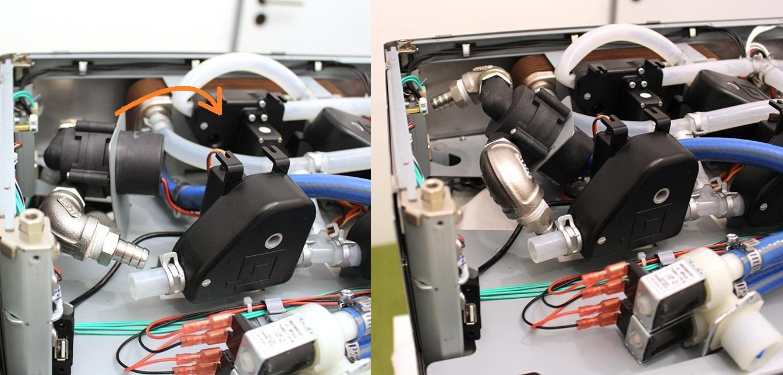

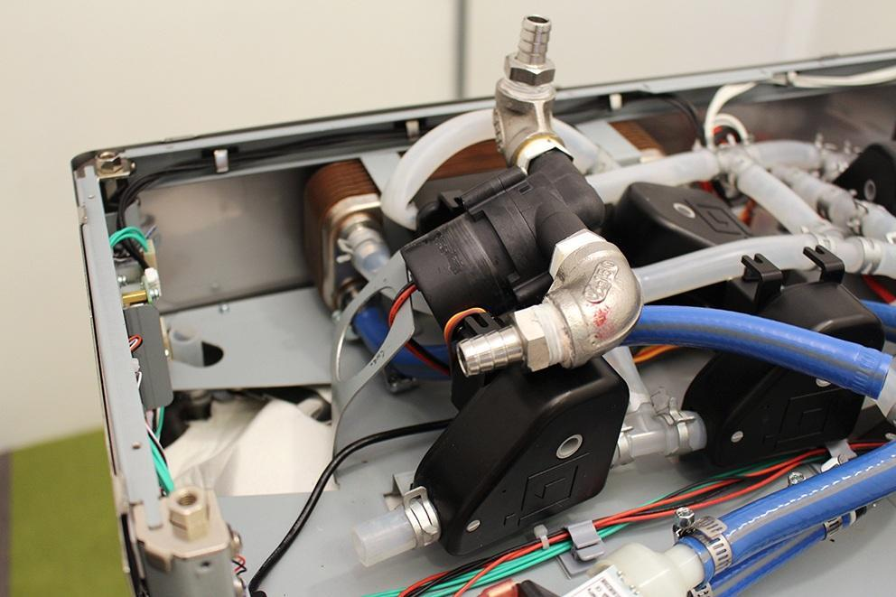

Remove the indexed valve (see at: “Remove the wort outlet valve”). Remove the heat exchanger holder clamps.

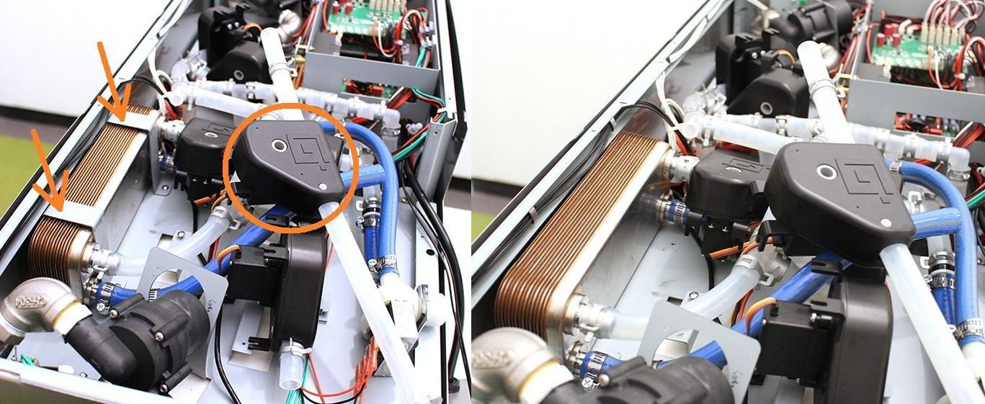

Unscrew the 4 indicated assembly plate screws.

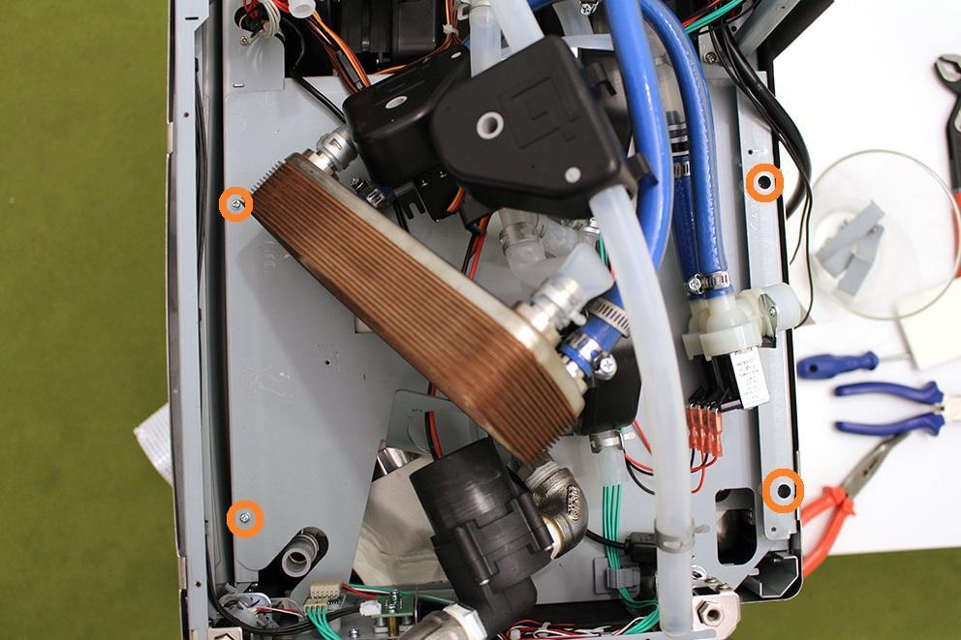

Disconnect the two indicated plugs, remove the cables from the indicated cable clips. Put the cables outside the machine in order to avoid the damage of the cables.

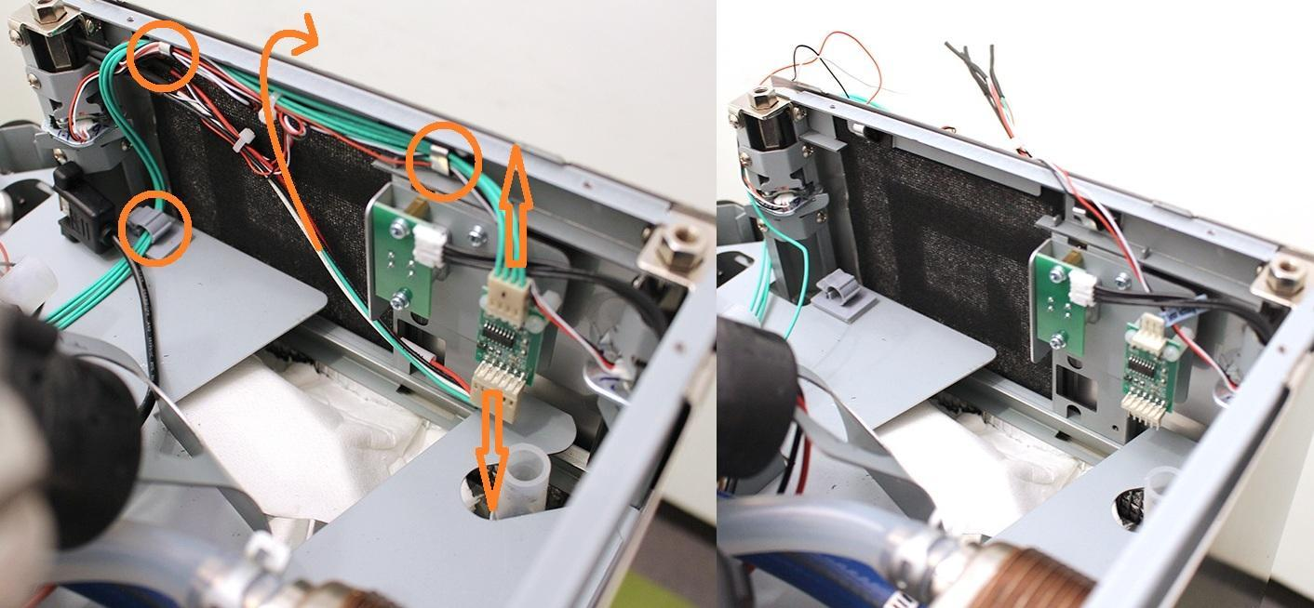

Remove the cables from the indicated cable clips.

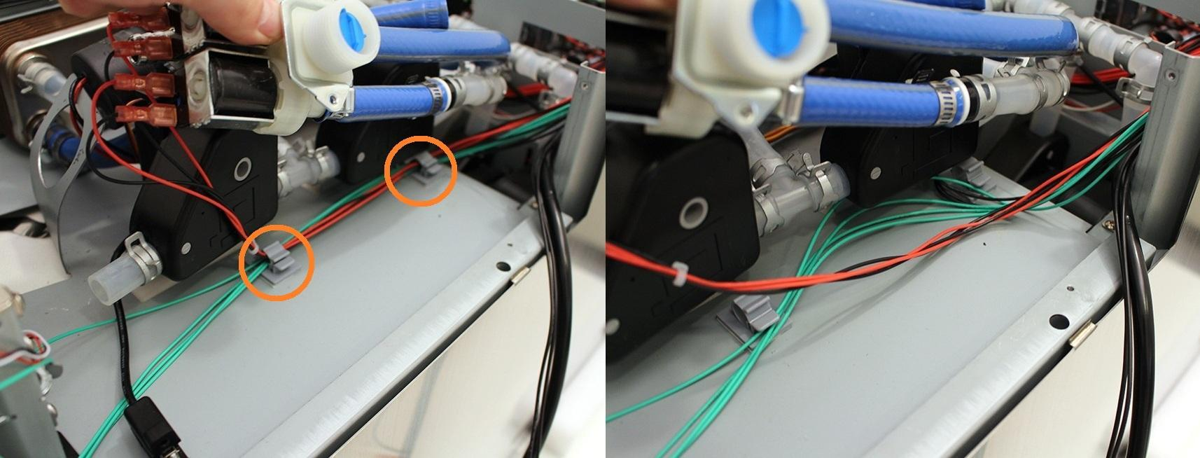

Remove the cables from the indicated cable clips. The right picture shows where to put the power and switch cords in order to avoid the damage of these cables.

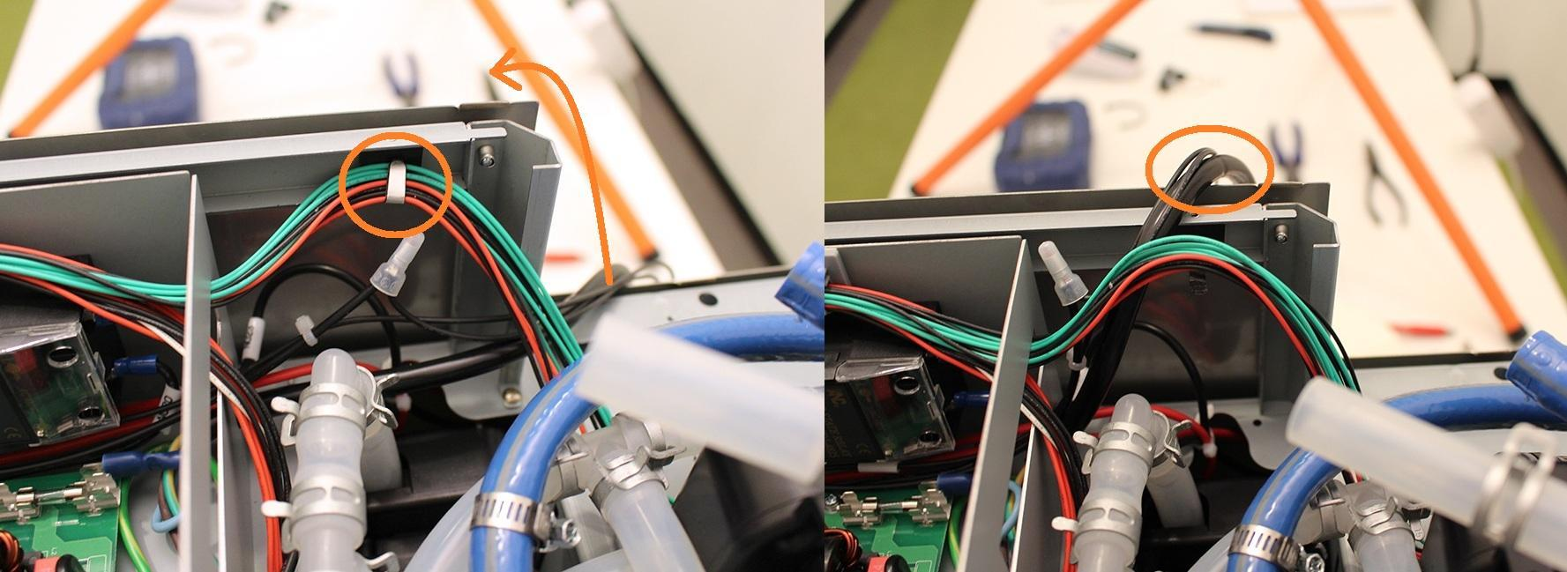

Remove the cables of the temperature sensor from the indicated cable clip. Avoid strain of this cable during further assembling.

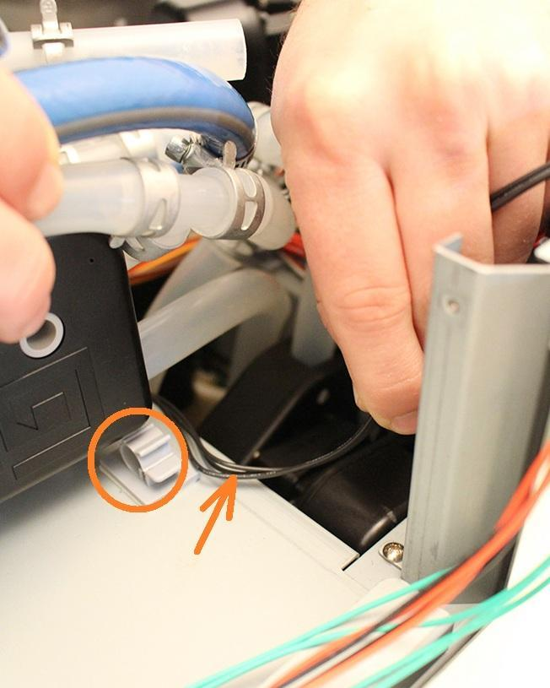

Disconnect the button plug, unscrew the indicated screws and remove the button unit.

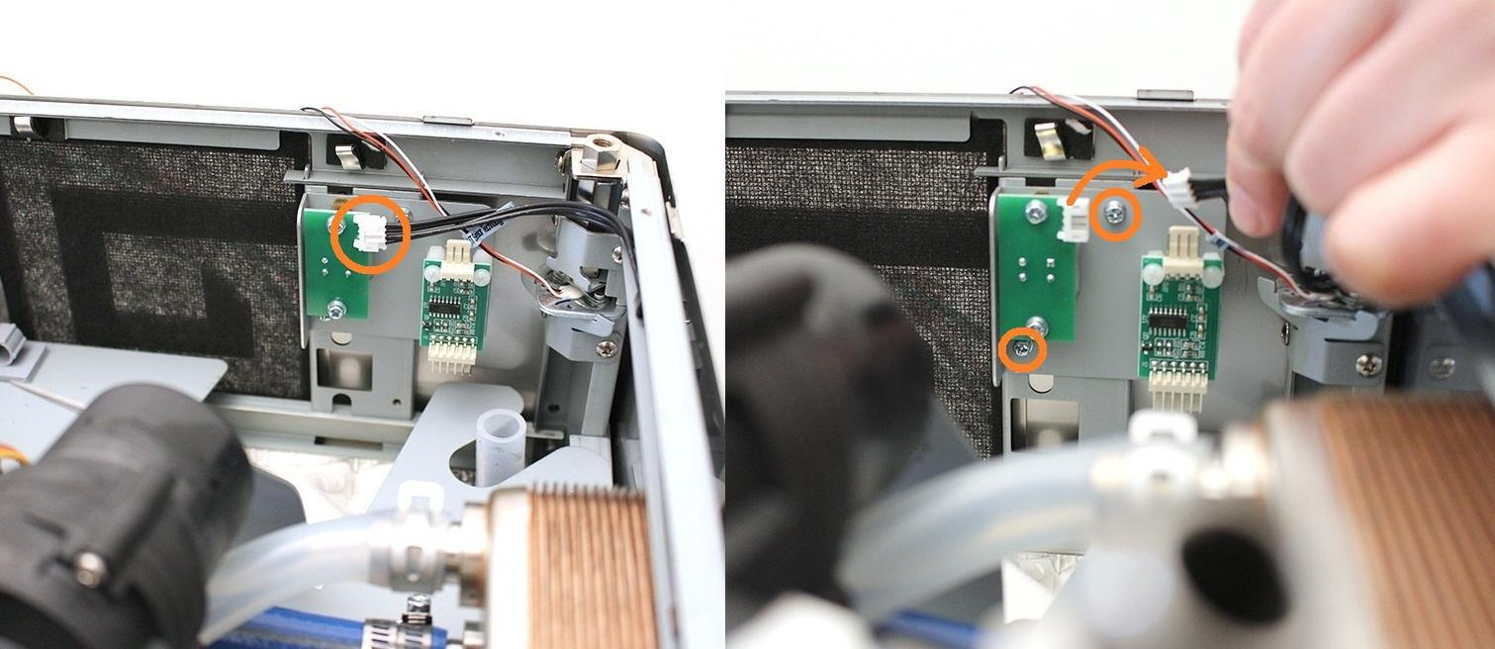

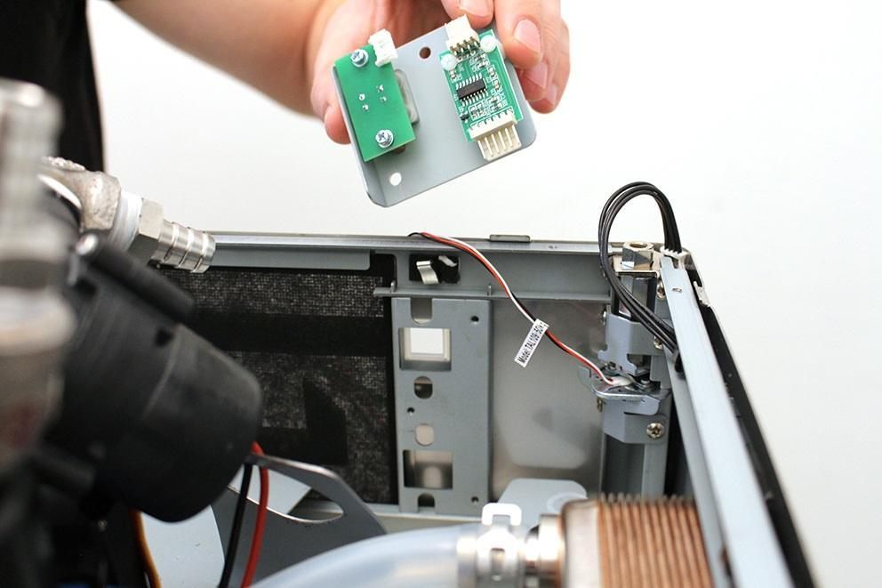

Loosen the screws of the two indicated valves, and remove them from their position.

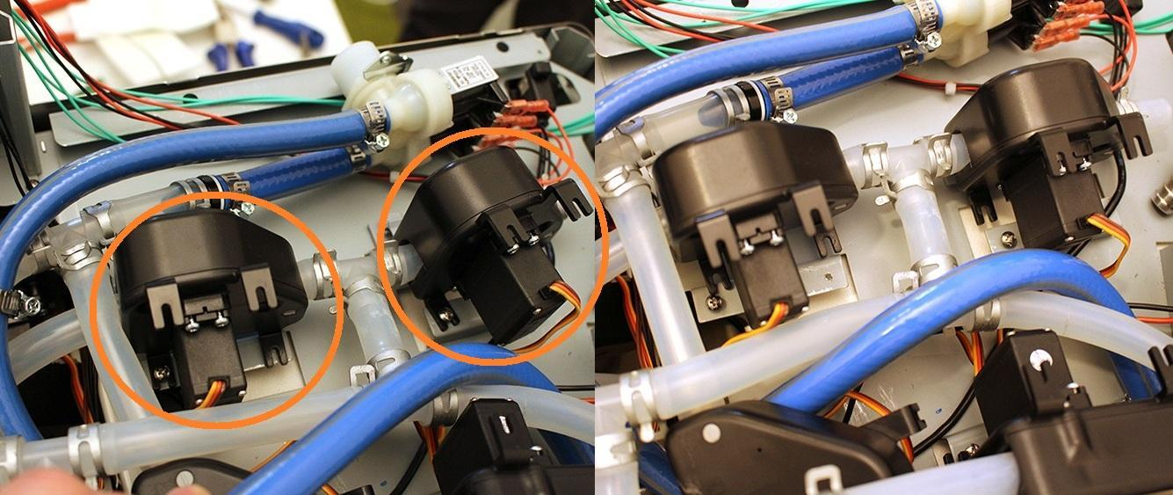

Lift the assembly plate carefully. Make sure not to damage the cables by the sheetmetal.

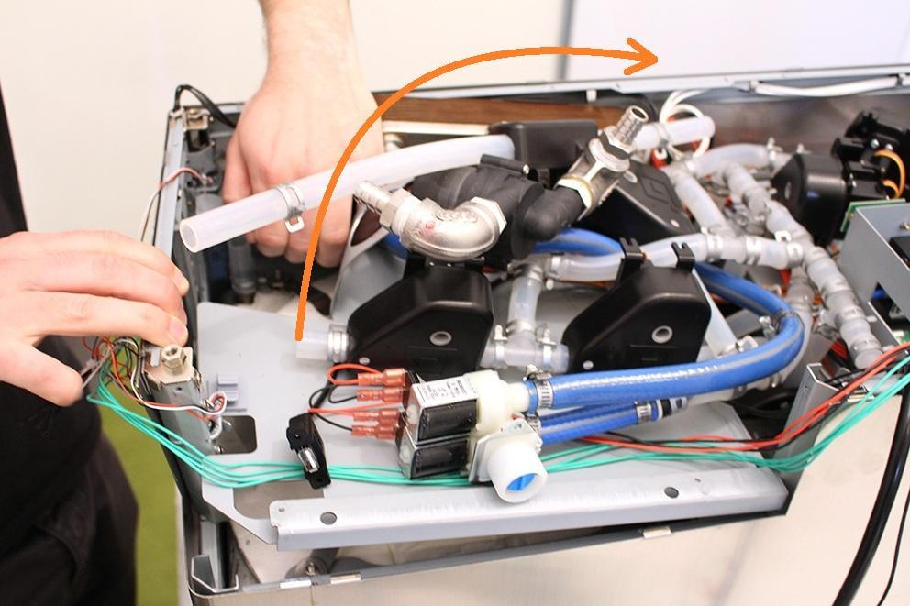

While lifting up the assembling sheetmetal, make sure not to damage the cables at the indicated areas.

It’s recommended to place the button plug as shown on the picture in order to avoid damage.

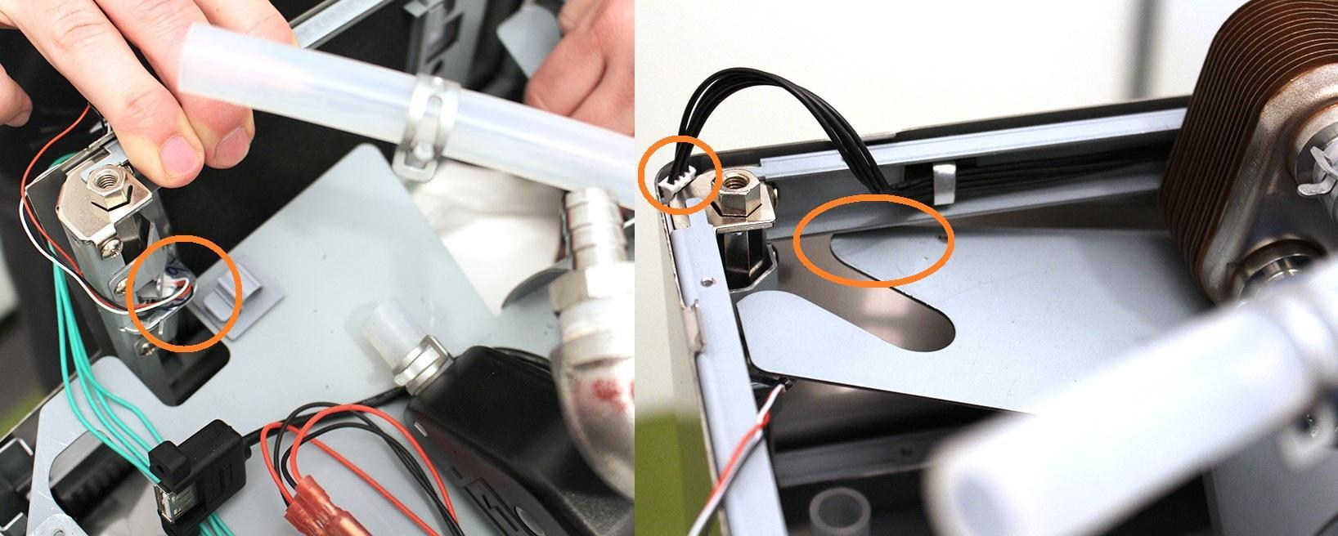

It’s recommended to fix the assembling plate with a soft object as shown on the right picture.(It must be soft to avoid the scratches on the cover of the machine).

Rotate the 4 indicated heat plate clamps to free the heatplate.

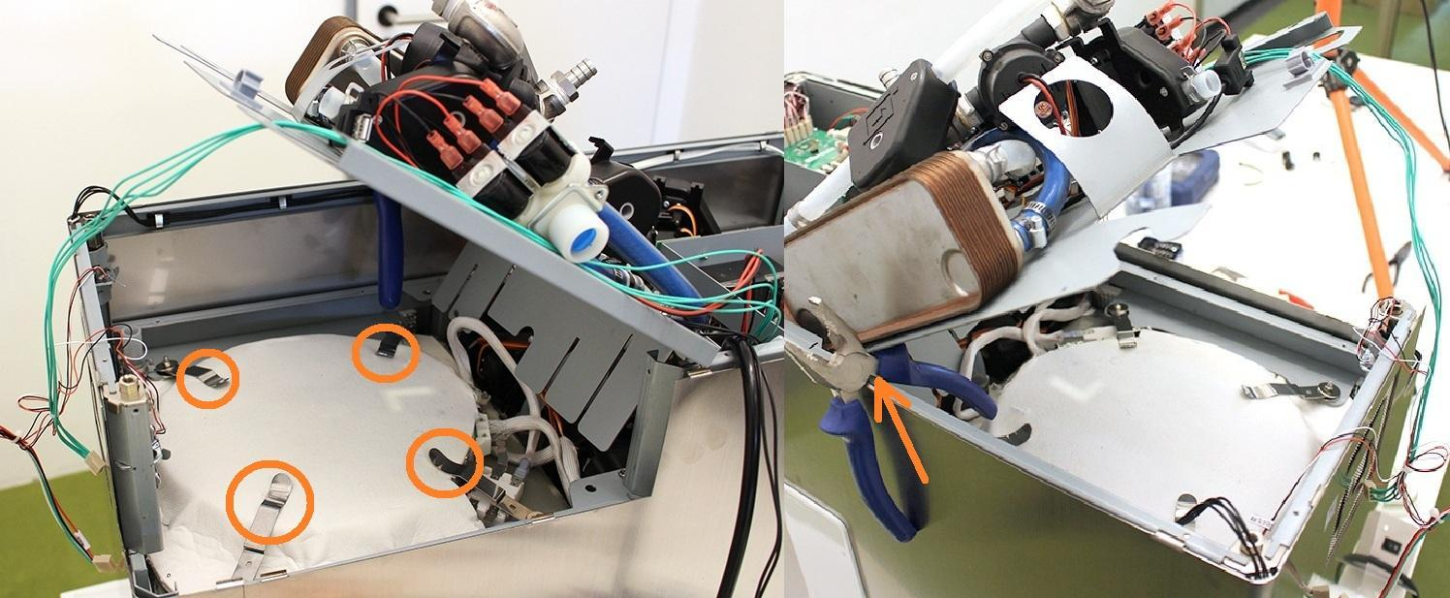

Remove the indicated heat plate cables.

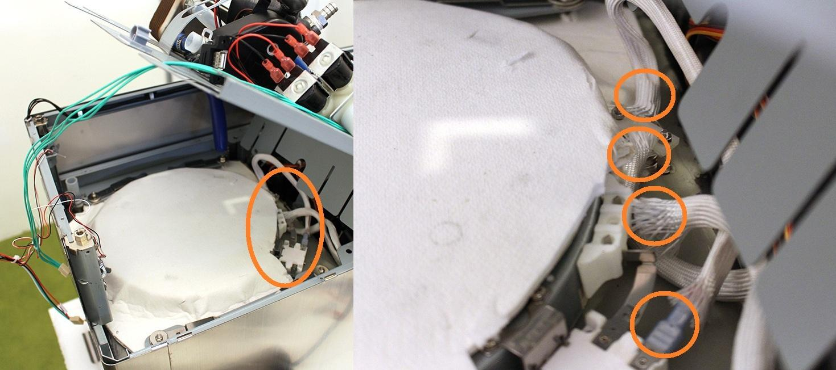

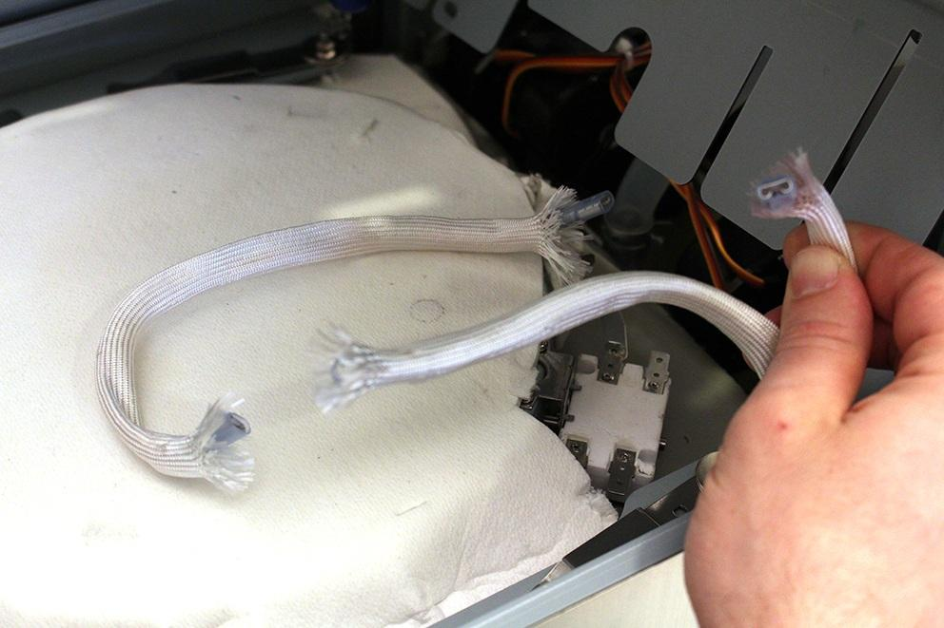

Carefully remove one side of the heat insulation.

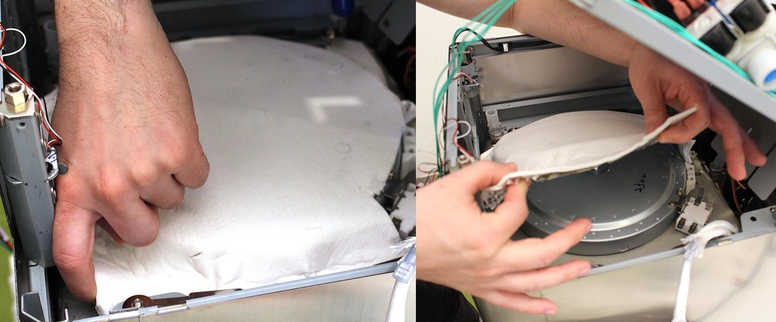

Now the heat plate can be removed.

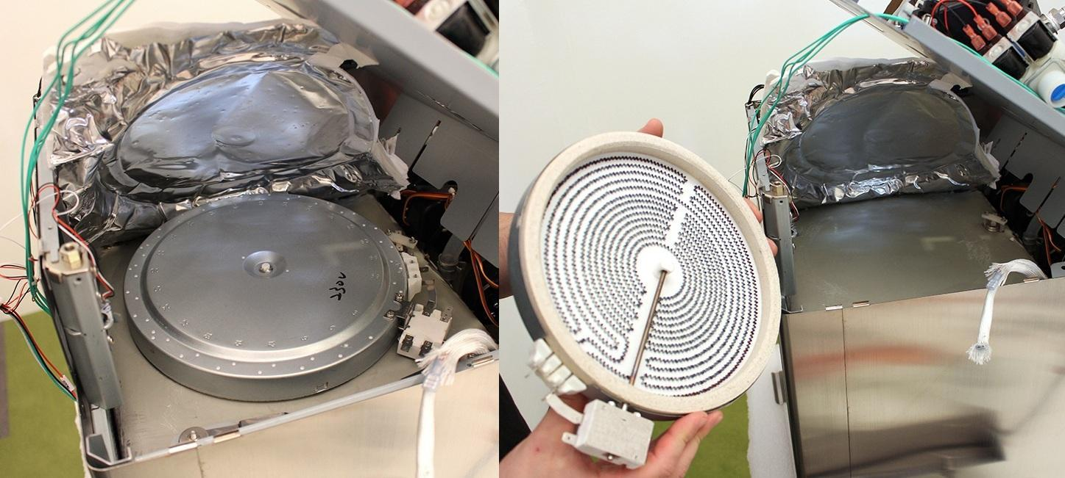

Replace the part.

Reassemble consists of the same steps in reverse.

While reassembling, take care of the followings:

1. Do not forget to rotate back the heat plate clamps!

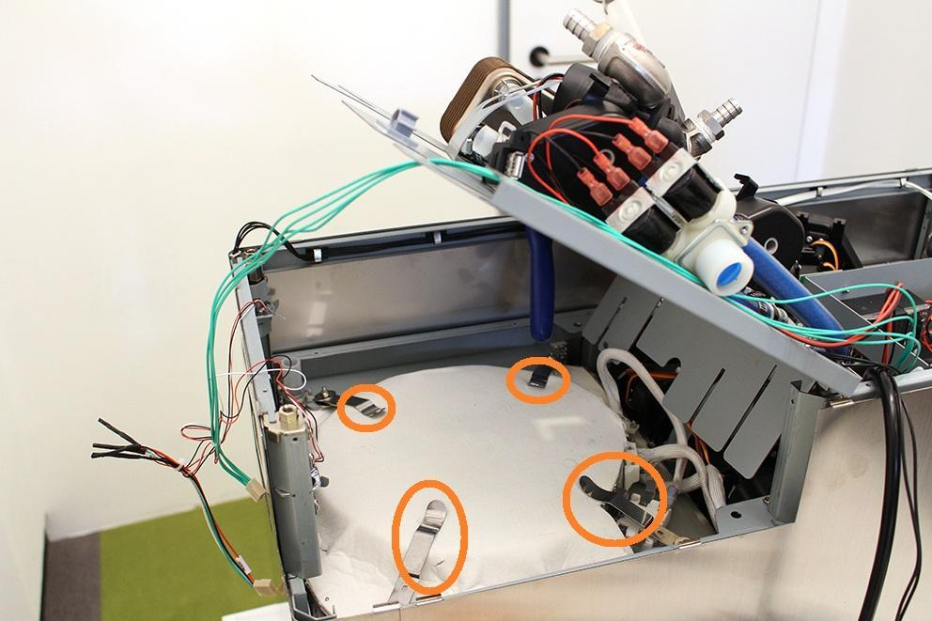

1. Be careful with cables while reassembling!   
    
2. Be careful with the silicone flange around the button while reassembling the button!

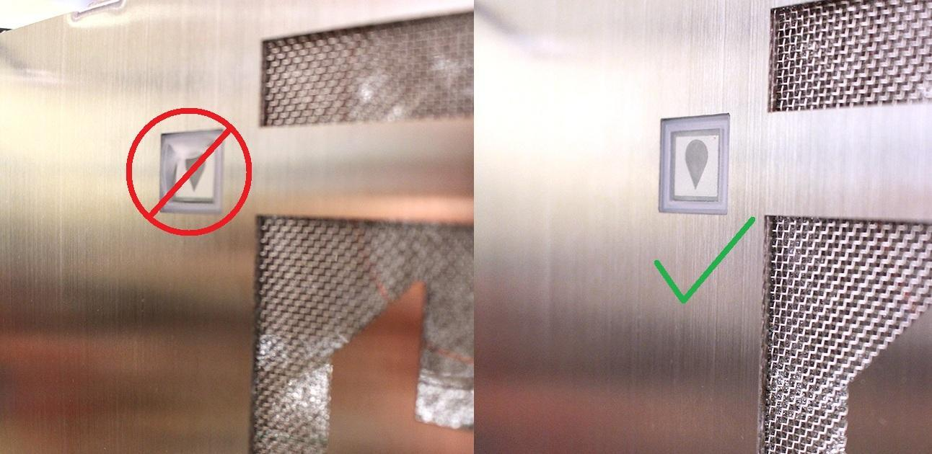

1. Make sure that the pumps are in the specified angle. Otherwise the pumps will not work properly. Use cable tie to fix the pump.

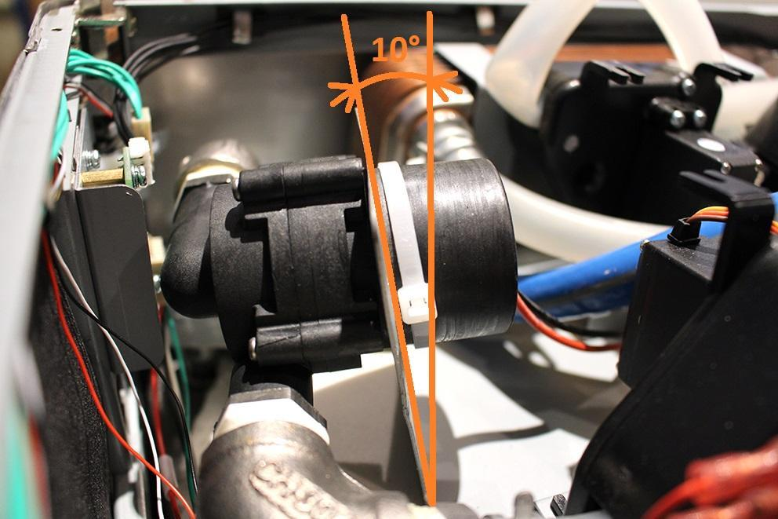

1. Place the heat insulation back to the original area.



1. Make sure that the wort outlet hose clamp is in the proper angle. Otherwise you cannot reassemble the lower sheetmetal.

